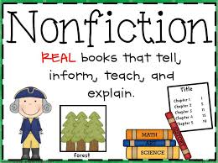
READING CHOICE BOARD
1st Grade NON-FICTION READING
After reading your NON-FICTION book, choose 1 reading response to write about in your HOMEWORK NOTEBOOK.
On top of your notebook page write the date, the book title,
author and illustrator, skip a line, then answer the question.
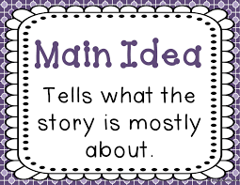  What is the main idea of the book? How do you know? | Tell about the 5 W’s after reading your non-fiction book. (who, what, when, where and why)  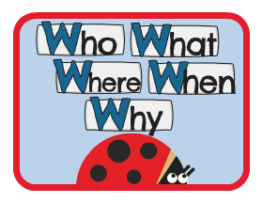 | What are 3 new vocabulary words you learned from your book and what do they mean?  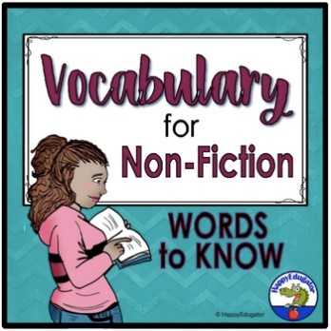
What are 3 questions you still have about your non-fiction book?  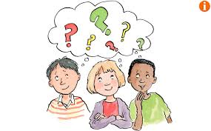 | Which text feature helped you the most?  Why that one?  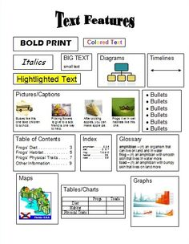 | Make and describe a connection between people, events or ideas in your book.  