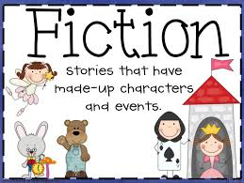
READING CHOICE BOARD
1st Grade FICTION READING
After reading your FICTION book choose 1 reading response to write about in your HOMEWORK NOTEBOOK.

On top of your notebook page write the date, the book title,
author and illustrator, skip a line, then answer the question.
Retell the story using the 5 finger strategy.  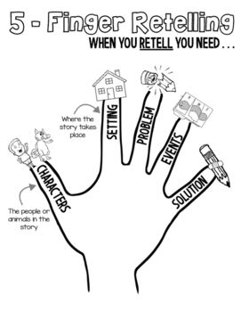 | What was the problem in the story and how was it solved?  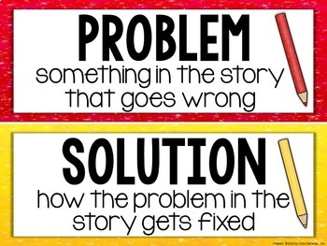 | Where is the setting of this story? Draw a picture and label it.  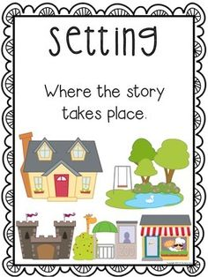
My favorite part of the story was when ____ because____. | 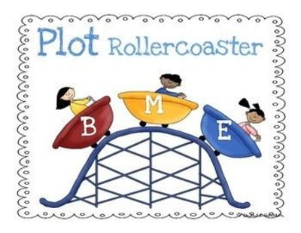  What is the plot? | What does the main character learn in this story?

